The Enrollment Cliff, Mega-Universities, COVID-19, and the Changing Landscape of U.S. Colleges

https://www.cpajournal.com/2020/11/13/icymi-the-enrollment-cliff-mega-universities-covid-19-and-the-changing-landscape-of-u-s-colleges/

By Paul Copley, PhD, CPA and Edward Douthett, PhD, CPA
Featured, COVID-19, September 2020, Analysis |
November 2020
Get Copyright Permission
IN BRIEF
The accounting academic and practitioner communities are closely intertwined, making the developments in one discipline of paramount importance to the other. As such, all CPAs should be aware of the current environmental factors facing U.S. higher education. Three in particular–the enrollment cliff, mega-universities, and COVID-19–have the potential to reshape the landscape of accounting education for years to come.
***
Perhaps nowhere else on American campuses is an academic subject more closely connected to the members of a profession than in the field of accounting. There is no discipline of accounting apart from the practice of accounting, and faculty are dedicated to preparing students for success in the profession. The profession has a vested interest in a continuous supply of entry-level candidates trained in financial reporting, controllership, attestation, and taxation. Members of both the academy and the profession serve advisory roles within the other’s organizations. Through a variety of firm-sponsored programs, practitioners keep faculty informed of developments within the profession, and faculty provide educational materials and research findings to improve practice. Just as it is important for academics to recognize changes taking place in the practice of accounting, it is important for the profession to understand the challenges and risks facing higher education. Three significant environmental factors are currently of major concern to U.S. colleges and accounting programs. All CPAs should take notice, as these items have the potential to reshape the landscape of accounting education.

The Enrollment Cliff
Enrollments at U.S. colleges and universities have fallen for eight consecutive years and are now below 18 million for the first time this decade (https://bit.ly/2DLB5hD). Recently, accounting programs have experienced a drop in accounting majors that outpaces this overall decline (A. Gabbin, “Warning Signs about the Future Supply of Accounting Graduates,” CPA Journal, September 2019). Demographic indicators point to things getting even worse for the nation’s colleges and universities. Between 2025 and 2029, the college-age population in the United States is expected to decrease by 15%.
Labeled the “enrollment cliff,” this decline is not caused by the rising costs of a college education or the declining value proposition of a college degree; rather, the problem is beyond the control of higher education institutions, specifically the nation’s fertility rate. The birthrate in a given year largely determines the college freshman population 18 years later. The number of children born in the United States fell precipitously between 2008 and 2011. Because the drop in fertility coincided with the 2008 financial crisis, the decline is frequently attributed to that event; it is worth noting, however, that the birthrate failed to rebound with the economic recovery and the college-age population is expected to continue to decline by 1–2% per year after 2029. Immigration has also fallen during recent decades; the number of permanent resident “green cards” issued reached a peak in 1991 at 1.8 million, but has varied between 840,000 and 1.2 million since 2000 (Department of Homeland Security Office of Immigration Statistics, https://bit.ly/3fT3Rdi.)
The most comprehensive examination of population trends and college enrollment is provided in Demographics and the Demand for Higher Education by Nathan Grawe, an economist at Carleton College in Minnesota (Johns Hopkins University Press, 2018). Using census information on the number of births and demographic characteristics correlated with college attendance, Grawe predicts college enrollments in the coming years. To get a better understanding of the effect of changing birthrates on different regions of the country, Grawe’s estimates of changes in college populations by U.S. census division are presented in Exhibit 1. His model predicts a decrease of 11% nationwide, but significant variation exists among regions. In absolute terms, the Middle Atlantic (NJ, NY, and PA) and East North Central (IL, IN, OH, MI, and WI) account for 56% of the overall drop in predicted college enrollments, but only 27% of the U.S. population.
Exhibit 1
Forecasted Changes in College-Age Population, by Census Division
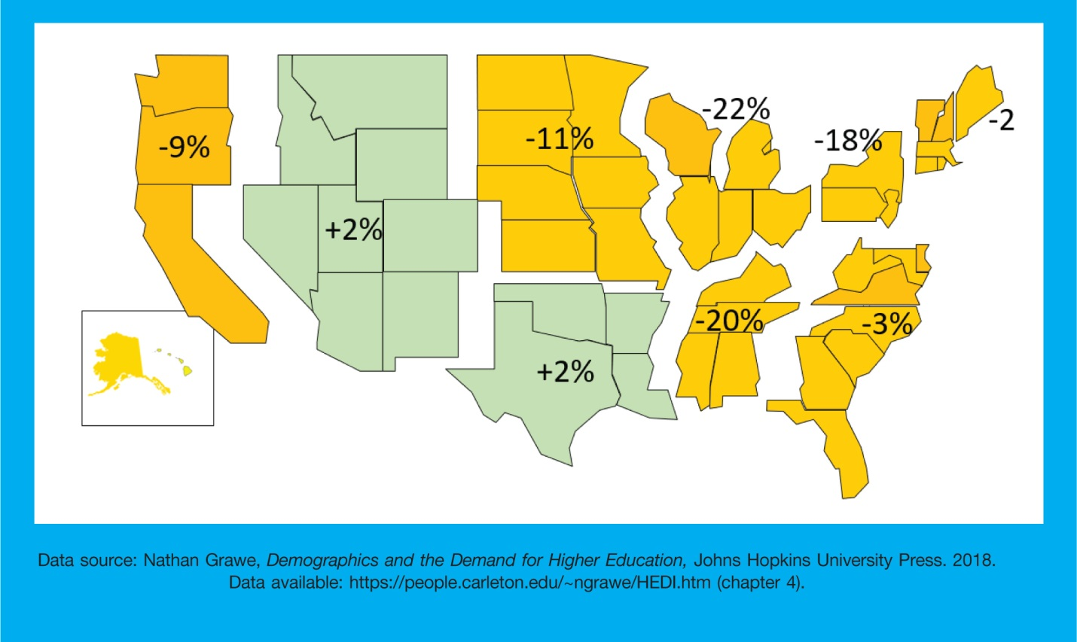
To appreciate the importance of college enrollment, it is useful to understand the business model of most universities. Assume that a university builds a state-of-the-art student recreation center that it believes it needs in order to remain competitive with other institutions vying for freshmen. The future debt service and upkeep of the recreation center requires either that the institution increase tuition (and fees) or increase the number of students paying tuition. Because higher tuition will presumably decrease enrollment, the better option is to attract more students. Every new facility or new program adds costs, however, and these are overwhelmingly fixed costs; they persist whether the college meets its enrollment targets or not. As a result, most institutions are not merely dependent upon maintaining student enrollment, but on increasing it.
In an era of decreasing enrollments, schools must also address the cost issue. Using data analytics to guide organizational restructuring, some schools are phasing out low-demand degree programs and shifting away from academic departments to interdisciplinary units. Eliminating programs takes several years, because schools are obligated to enable students to complete programs in which they are currently enrolled.
Of course, the enrollment crisis is not bad news for everyone. Children who are currently in elementary school will enter college at a time when schools are aggressively competing for students. Already, public universities are finding it difficult to increase tuition and private colleges are offering more generous financial aid packages. Within select majors, some public universities are waiving the tuition premium normally charged to out-of-state students. More openly than in the past, schools now recognize that they can better maintain enrollments if they reduce dropout rates. There is a growing emphasis on student success initiatives, such as frequent advisor meetings, tutoring, financial support, and student life programs.
The enrollment cliff is a looming crisis within higher education, and nearly all schools are looking to develop better marketing strategies. The problem is that if these efforts are directed to the same shrinking pool of students, not every school will be successful despite spending more. Most agree that it is better to identify potential new sources of students. For example, there are efforts to recruit more working adults, first-generation students, and international students. Enrollments of international students in U.S. colleges has fallen 6% per year since 2016, with the largest decrease being seen in business majors; during the same time period, colleges in Canada have reported annual increases of 15–20%. The conclusion is that there exists demand by international students to study in English-speaking universities, but U.S. colleges are having difficulties attracting international students. Among factors contributing to this change are the effects of recent administration policies such as increased scrutiny of F-1 visa applications, anti-immigrant rhetoric, and concerns on the part of prospective students about safety following highly publicized campus shootings.
A study of census data by the Pew Research Center provides some encouraging detail about the current generation of college students (https://pewrsr.ch/3iE0cBV/). The study compares Americans born between 1997 and 2012 (the “postmillennial” generation) with earlier generations, including the millennials (1981–1996). It is clear from the findings that the decline in birthrate was not uniform across demographic groups. One in four postmillennials are Hispanic, and non-Hispanic whites now comprise only a slight majority (52%) of the population. These proportions are significantly different than the previous generation (18% and 61% respectively for millennials). In western states, the proportions of postmillennial Hispanics and non-Hispanic whites are now equal (40%).
Most encouraging for higher education is the proportion of 18- to 20-year-old adults currently enrolled in college. Compared to the preceding generation, college enrollment percentages are higher for every demographic group, with notable increases for Hispanics (from 34% to 55%), Blacks (from 47% to 54%), and women (from 57% to 64%). The increase in college-bound percentages may be explained by other factors reported in the Pew study. Postmillennials are more likely to have been born in the United States and more likely to be living with at least one parent who has a bachelor’s degree (from 32% to 43%).
Public accounting firms should be at the forefront in recruiting minorities. Demographic trends indicate that higher proportions of college students will fall into historically underrepresented groups. It is increasingly important that firms aggressively recruit these students in the future. Similarly, accounting programs need to actively encourage minority students if the downward trend in accounting majors is to be halted.
U.S. colleges and universities view international students as one of their best opportunities to boost enrollments.
Accounting employers have historically been reluctant to hire international students. Nevertheless, U.S. colleges and universities view international students as one of their best opportunities to boost enrollments. To address the enrollment cliff, colleges will likely pursue larger numbers of international students. The time may have now come for firms to reconsider their reluctance to sponsor international candidates, as the overall pool is shrinking and many of the most qualified candidates will be non-U.S. citizens.

Mega-universities
The last decade has seen the rise of mega-universities, including Liberty, Grand Canyon, Southern New Hampshire, and Western Governors universities. Characterized by massive online enrollments, each has an interesting and distinctive history.
Founded by Jerry Falwell in 1971 as Lynchburg Baptist College, Liberty University is a private nonprofit university with a residential campus of 15,000 students and online programs enrolling 95,000. Liberty began its distance learning programs in 1985 by mailing VHS tapes to students, but greatly expanded its offerings and enrollment following the advent of high-speed Internet access.
Like Liberty, Grand Canyon University started as a nonprofit college associated with the Baptist denomination. In 2004, GCU was sold to an LLC and is classified by the Department of Education as a for-profit university. The only for-profit school to participate in NCAA Division 1 athletics, GCU has more than 90,000 students, of which 70,000 are enrolled online.
Previously named the New Hampshire College of Accounting and Commerce, Southern New Hampshire University started as a for-profit college but reorganized itself as a nonprofit university. Facing increasing costs and declining enrollments throughout the early 2000s, SNU changed its focus in 2009 to online offerings. Using more than 5,000 part-time faculty, SNU’s enrollment now exceeds 90,000 students, of which 87,000 are enrolled online.
Western Governors University was founded in 1997 based on a proposal floated at a meeting of the Western Governors Association (1995) to expand educational offerings over the Internet. Nineteen U.S. governors each contributed $100,000 toward the founding of a self-sustaining private nonprofit university which now has over 110,000 students. WGU differs from the other mega-universities in that its courses are only offered online and the 2,000 faculty are almost exclusively full-time.
Colleges that are adept at identifying the needs of adult learners and providing programs that meet those needs will succeed in the online marketplace.
The success of these mega-universities has been attributable to their appeal to a segment of the population largely overlooked by traditional four-year schools. Their target customers are the estimated 30 million Americans who have some college education but never completed a degree (https://bit.ly/2DPIUCO). The flexibility afforded by an online format appeals to working adults. These universities have also responded to the desires of their customers by offering programs focused on those career credentials that enable their students to get better jobs. These universities promote competency-based education, which allows students to earn credits by demonstrating proficiency in a subject through life experience as well as academic study. Much of the success of mega-universities is attributable to an emphasis on student service and aggressive marketing.
All four of these universities offer bachelor’s and master’s degrees in accounting. Additionally, students may pursue degrees in related areas, including data analytics and cybersecurity. However, the geographical dispersion of the student population presents challenges in recruiting students from these schools. Traditional practices of recruiting by region with on-campus interviews and social events are not likely to be effective. Alternatives are available—for example, one major accounting firm announced last year that it would replace all on-campus interviews with video interviews. Recently, the coronavirus (COVID-19) crisis has forced employers to move entry-level recruiting to phone or videoconferencing. These methods could be promoted on virtual campuses, and thereby firms could access a larger pool of candidates.
Large online programs are not limited to the few mega-universities. Arizona State, Purdue, and the University of Maryland are among the public universities that have online programs which enroll tens of thousands of students. Because most U.S. colleges offer courses or entire degree programs in online format, it may be tempting to view online education as a solution to the pending enrollment crisis. Competing directly with the online programs of large public and mega-universities will be difficult, given their low tuition and large investments in marketing. The nature of careers has changed, however, with the result that individuals periodically require new job skills throughout their career. Colleges that are adept at identifying the needs of adult learners and providing programs that meet those needs will succeed in the online marketplace.

Impact of COVID-19
It is too early to determine the full effect of the coronavirus (COVID-19) pandemic on U.S. colleges. Most schools remained open throughout spring 2020 but moved classes to an online format. Students were issued refunds for prorated portions of dormitory fees and meal plans; these auxiliary activities, however, represent only about 10% of revenues for a typical college. Other immediate-term costs include sanitizing facilities, providing protective materials for employees, and purchasing equipment and software for faculty to provide online instruction. At the same time, there are some opportunities for savings if costly events, such as commencement ceremonies, are curtailed.
Of greater concern is the effect of the pandemic on enrollments. Students had little choice other than to complete their spring classes online. However, participation in summer sessions is largely discretionary and students may simply choose not to enroll in the fall if they are dissatisfied with the online format. Summer is also the primary term for study abroad, and those programs were cancelled. Freshman enrollments, already in decline, are likely to be affected as some families opt for a “gap year” between high school and college to await the development of vaccines or simply to see how the pandemic plays out. Even more worrisome will be the loss of international students whose out-of-state tuition is an increasingly important portion of public university budgets.
The immediate effect among nearly all colleges and universities will be postponement of faculty hires, curtailment of new programs, nonrenewal of adjunct faculty contracts, and cuts in discretionary spending, such as facility upgrades, travel, and research funding. Faculty and staff salaries represent universities’ largest expenditures. Both private and state universities have announced salary cuts and furloughs to make up for pandemic losses. The Coronavirus Aid, Relief, and Economic Security Act (CARES Act) provides $14 billion to colleges and universities, but at least half must be used for emergency financial aid grants to students. Not all schools qualify and the amount a school receives depends on its number of Pell Grant–eligible students.
Public universities rarely close. Rather, it is more common for financially stressed institutions to be merged with others within the state system to attain administrative efficiencies. Enrollment-dependent small private colleges, particularly those without strong endowments, will be most vulnerable. Prior to the pandemic, Moody’s estimated that one in five small colleges experience financial stress (https://bit.ly/3gYY5rY).
While the current crisis will likely push some of these to close or merge, the historical rate of closure is low (about 1% per year), often due to the inflow of alumni contributions in times of crisis. Matters will certainly become much worse if the COVID-19 pandemic is followed by a prolonged economic recession.
Matters will certainly become much worse if the COVID-19 pandemic is followed by a prolonged economic recession.

Watching for the Cliff
It is important for CPAs to understand the current conditions and near-term factors affecting U.S. colleges and universities. Faculty should understand the financial impact of competition and declining enrollments if they are to help their institutions prosper. Many more accountants serve on boards of universities, colleges of business, or accounting programs; they can be more effective in that advisory role if they understand the challenges facing the programs they support. Mega-universities, with their large enrollment of non-traditional students, may increasingly compete for the same students that traditional universities are seeking to attract. Although no one can predict the ultimate outcome of the global COVID-19 pandemic, it is clearly poised to have a significant impact on colleges and universities during the coming school year, and possibly much longer.
College recruiting is the lifeblood of professional services firms. Accounting enrollments have declined in recent years, increasing the competition for qualified candidates. All factors suggest that this competition is likely to increase in the near term. Firms will be more effective if they plan for further reductions in the supply of accounting graduates and explore ways to reach candidates outside of their traditional sources.
Paul Copley, PhD, CPA, is the RSM Faculty Scholar in the James Madison University School of Accounting, Harrisonburg, Va.
Edward Douthett, PhD, CPA, holds the Northern Chapter of the Virginia Society of CPAs Professorship of Public Accounting at George Mason University, Fairfax, Va.
TAGS: higher education education accounting academy

