Accounting Education at a Crossroads
Does a Drop in Enrollment Foretell a Decline in the Marketplace?

https://www.cpajournal.com/2020/09/30/accounting-education-at-a-crossroads/

By Alexander L. Gabbin, PhD, CPA, James H. Irving, PhD, CPA and Eileen M. Shifflett, CPA
Featured, September 2020, Feature Articles, Analysis |
September 2020
Get Copyright Permission

IN BRIEF
The authors’ university has seen a significant drop in accounting enrollment from 2015 to 2019. The results of a survey by the authors suggest that this trend is common across top-tier accounting programs. Students’ perceptions about the value of a traditional accounting education, and the value of the credential in the marketplace, appear to be in decline.
At the authors’ institution, James Madison University, enrollment in the intermediate accounting course sequence has dropped a stunning 34% over the past four years (see Exhibit 1). This course sequence is a primary metric relied upon by both the accounting faculty and major employers of accounting students. It is the gateway for accounting majors, with 98% of the university’s 2019 Master of Science in Accounting graduates entering public accounting upon graduation. Of the university’s 2019 Bachelor of Business Administration graduates who entered the workforce, 93% joined public accounting firms.

Exhibit 1
Intermediate Accounting Student Enrollment
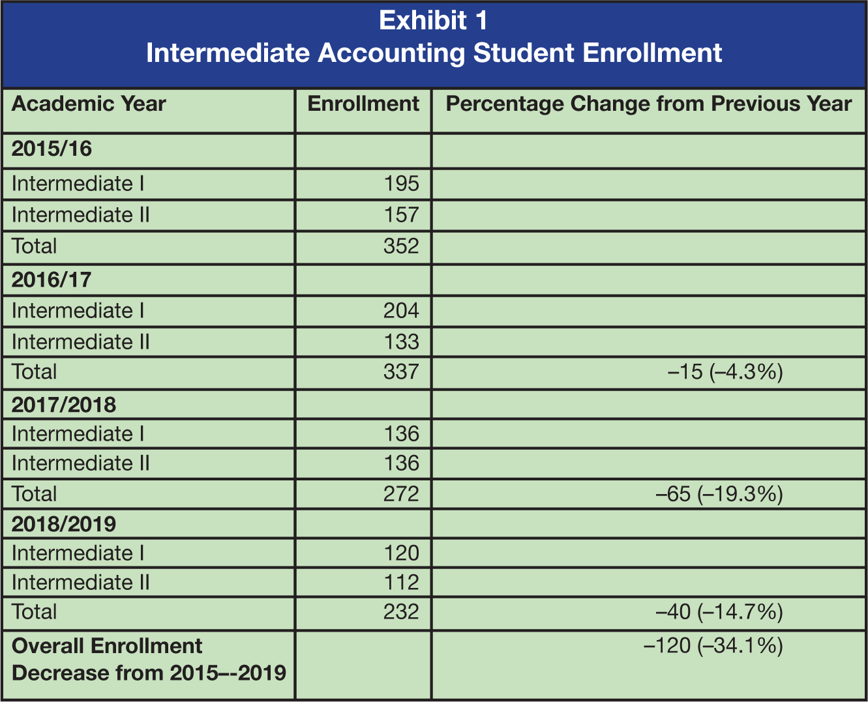
In an effort to better understand what has been happening at their own university in the context of enrollment in similar accounting programs, the authors sent a brief survey to obtain feedback from accounting colleagues in leadership or program administration positions at 78 U.S. colleges and universities (see Appendix 1 for the survey instrument). The target institutions were programs that have been successful in educating students who want to become CPAs.
The sample of institutions was chosen based on the CPA Examination Board’s ranking of first-time pass rates for large and medium-sized programs (see Appendix 2 for the list of schools). The top 40 large programs are institutions with more than 60 reported candidates and an average first-time CPA pass rate of at least 68.5%. The top 40 medium-sized programs are institutions with 21 to 60 reported candidates and an average first-time CPA pass rate of at least 62.1%.

Results
For large programs, Exhibit 2 shows a response rate of 43.6% (17 of 39 institutions). The authors interpret this high response rate to be indicative of a widespread interest among program administrators about accounting enrollment. Since the 2015/16 academic year, Exhibit 2 shows that 13 of 17 respondents (76.4%) in large programs reported a noticeable decrease in accounting enrollments. Only 2 respondents (11.8%) reported a noticeable increase, while another 2 respondents (11.8%) have not seen a noticeable change in enrollment. The results reflect a similar picture for medium-sized programs from 2015 to the present, with 7 of 14 respondents (50%) reporting a noticeable decrease in accounting enrollments and the other 7 respondents (50%) indicating there has been no noticeable change. No respondent among medium-sized programs reported a noticeable increase in accounting enrollment.
Exhibit 2
Accounting Program, Change in Enrollment
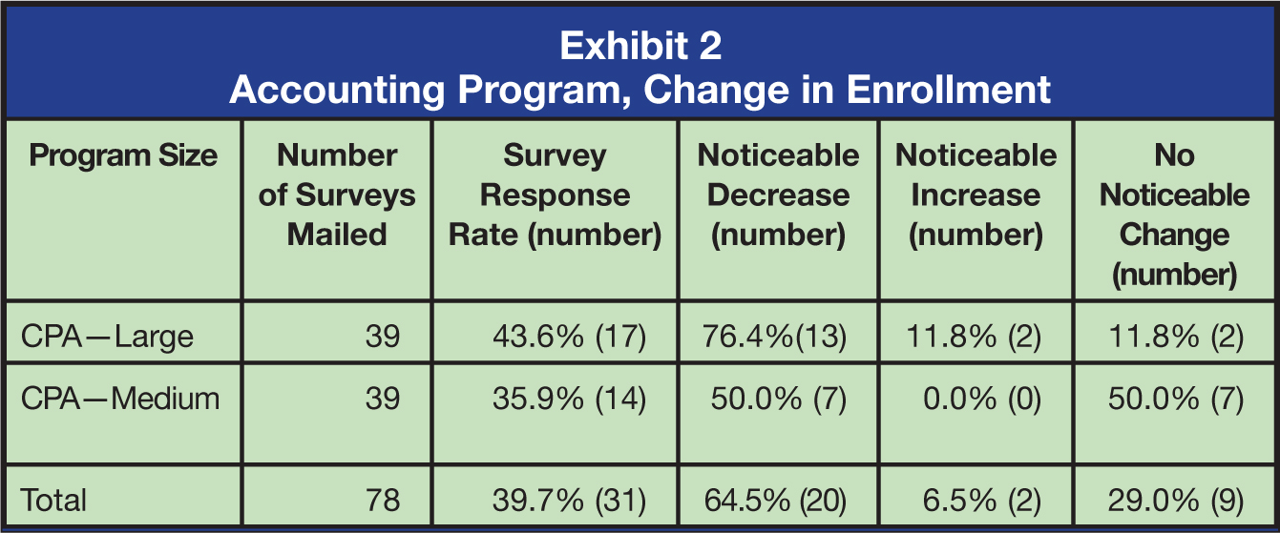

Analysis
Among the 78 large and medium-sized programs combined, 20 of 31 respondents (64.5%) reported a noticeable decrease in their accounting enrollment in recent years, while only 2 of 31 respondents (6.5%) reported a noticeable increase. What are the implications of this? In the authors’ opinion, Exhibit 2 is a warning that the enrollment shift observed at our institution is not an anomaly. These survey findings are further corroborated by the AICPA’s 2019 Trends in the Supply of Accounting Graduates and the Demand for Public Accounting Recruits (AICPA, https://bit.ly/2PyPvDS). In programs across the nation that educate the best and brightest students for public accounting careers, something is negatively affecting the desirability of accounting as a major.
Unlike the period when U.S. licensing jurisdictions began moving to the 150-hour education requirement, the cause of this decline in enrollment is not easily traced to a temporary disruption. For example, in their study examining “the number of first-time candidates after implementation of the 150-hour requirement as a percentage of candidates before enactment,” Shafer, Kunkel, and Hansen reported that “for most states there was a dramatic reduction in the number of candidates immediately after the requirement went into effect.” (“Effects of the 150-Hour Education Requirement,” The CPA Journal, January 2003). For the enrollment decline in top-tier programs since 2015, however, no single, identifiable factor explains the current movement away from accounting as a major, nor is there any evidence to suggest the decline is temporary. The reasons are likely complex and will require careful study before conclusions can be reached.
Yet there is reason to fear that accounting majors could become second-class citizens in the new professional marketplace. Dismissing the current enrollment decline at top-tier programs as short-term and easily fixed is unwise. Exhibit 3 offers opinions cited by respondents as possible reasons for the decreases in program enrollment. It is worth noting that the three most commonly cited explanations include “a strong job market for other majors which do not require 150 hours,” “emergence of tech-related majors,” and “starting salaries for entry-level accountants have remained stagnant.”

Exhibit 3
Reasons Cited for Noticeable Decrease in Accounting Enrollment
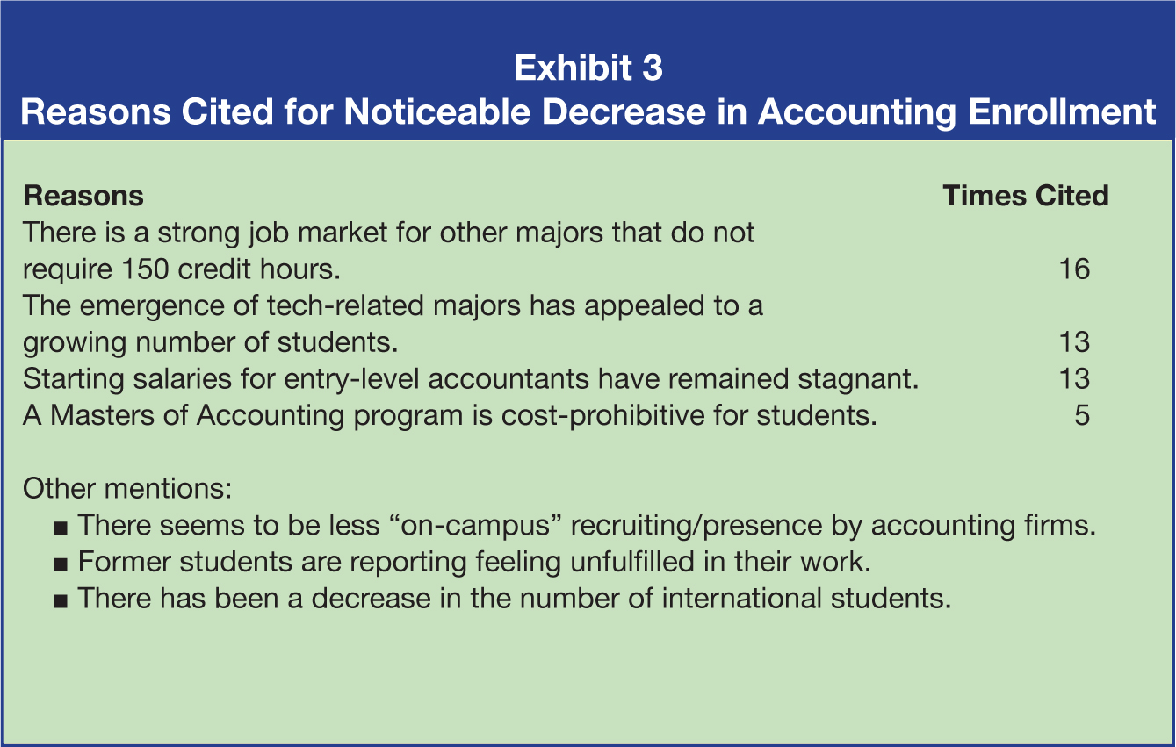

Paradigm Shift in the Marketplace?
An unavoidable truth that accounting educators must face is that public accounting firms seem less interested in hiring traditional accounting graduates. Reporting indicates, for example, “CPA firms are turning to nonaccounting graduates in increasing number” and “overall hiring of new accounting grads is down” (K. Tysiac, “Report Finds Shift in Accounting Firm Hiring,” Journal of Accountancy, August 13, 2019, http://bit.ly/2ONqvIh). One cannot deny that many of the best and brightest students may no longer be as interested in accounting careers.
In today’s rapidly changing, technology-driven business environment, the set of skills emphasized in the past is becoming relatively less relevant in comparison with the set of skills that are most desirable to employers and students. As a result, the authors believe that accounting education has come to a crossroads. A paradigm shift in the marketplace is occurring, and students—as well as employers of accounting majors—are responding to marketplace incentives.
It is highly plausible that enrollments are decreasing at institutions like James Madison University because students are shifting to areas that provide a better match between program major and compensation upon graduation. More likely than not, employers of accounting majors are not willing to pay more to accounting majors because the CPA firms may no longer consider traditional accounting degrees to be as valuable as they once were.
Researchers acknowledge that “the advent of data analytics and big data is not a fad; it is a real phenomenon driven by new technologies being adopted by many businesses. Accountants and auditors are very much behind the curve” (A. Kogan, M. A. Vasarhelyi, D. Appelbaum, “Introduction to Data Analysis for Auditors and Accountants,” The CPA Journal, February 2017, https://bit.ly/2F8Oh0g). While no one disputes the importance of accounting graduates possessing both the excellent communication and technical accounting skills needed in today’s complex business environment, each of the Big Four firms has been signaling to accounting educators the critical importance of also developing an appropriate level of expertise in data analytics (L. Hart, “Educator Resources from the Big Four,” Journal of Accountancy, June 12, 2018, https://bit.ly/3kzkuy4).
For accounting programs to retain their share of the best and brightest students, early indications suggest they must teach accounting majors the skills employers now want—and send clear signals to the marketplace that accounting graduates possess those skills. Hopefully, individual programs will find their accounting advisory boards to be valuable partners in providing resources and other support in this regard.
Expertise at describing past transactions and generating standard reports will continue to be vitally important. However, in a future-oriented marketplace that now values such skills as “identifying patterns in historical data” and “identifying the best option to choose to achieve the desired outcome,” accounting programs that do not adapt may continue to see this recent enrollment trend persist (N. Tschakert, J. Kokina, S. Kozlowski, and M. Vasarhelyi, “The Next Frontier in Data Analytics,” Journal of Accountancy, August 1, 2016, https://bit.ly/33TU58f).
Alexander L. Gabbin, PhD, CPA is the KPMG LLP Professor at James Madison University, Harrisonburg, Va.
James H. Irving, PhD, CPA is an associate professor of accounting and Keiter Faculty Scholar at James Madison University.
Eileen M. Shifflett, CPA, is a lecturer of accounting and Veris Consulting Faculty Scholar at James Madison University.
APPENDIX 1[Question 1] Since 2015, what type of change in the number of accounting majors has occurred at the undergraduate level at your institution?
There has been a noticeable decrease.
There has been a noticeable increase.
There has been no noticeable change.
N/A – my institution does not have an undergraduate accounting program.
[Q1a] If you answered noticeable decrease to Question 1, what factors do you feel have led to this decrease? Please select all that apply.
A masters of accounting program is cost-prohibitive for students.
The emergence of tech-related majors has appealed to a growing number of students.
Starting salaries for entry-level accountants have remained stagnant.
There is a strong job market for other majors which do not require 150 hours.
Other ______________________________
[Q1b] If you answered noticeable increase to Question 1, please explain the factors you believe have led to this increase.
[Question 2] Since 2015, what type of change in the number of accounting majors has occurred at the graduate level at your institution?
There has been a noticeable decrease.
There has been a noticeable increase.
There has been no noticeable change.
N/A – my institution does not have a graduate accounting program.
[Q2a] If you answered noticeable decrease to Question 2, what factors do you feel have led to this decrease? Please select all that apply.
A masters of accounting program is cost-prohibitive for students.
The emergence of tech-related majors has appealed to a growing number of students.
Starting salaries for entry-level accountants have remained stagnant.
There is a strong job market for other majors which do not require 150 hours.
More students are completing 150 credit hours during their undergraduate studies.
Other ______________________________
[Q2b] If you answered noticeable increase to Question 2, please explain the factors you believe have led to this increase.
APPENDIX 2
LARGE PROGRAMS MEDIUM-SIZED PROGRAMS
Rank Institution Rank Institution
1 Wake Forest 1 Messiah College
2 Wisconsin-Madison 2 Truman State
3 Florida 3 Beth Medrash Govoha
4 BYU 4 Vermont
5 Notre Dame T5 Trinity
6 Georgia T5 Shippensburg
7 Boston College 7 Washington & Lee
8 Missouri-Columbia 8 Calvin College
9 Virginia 9 Holy Cross
10 Texas-Austin 10 Bucknell
11 Tennessee-Knoxville 11 Grove City College
12 Miami (FL) 12 Butler
13 Michigan 13 Hope College
14 Texas A&M 14 Rhodes College
15 North Carolina-Chapel Hill 15 Vanderbilt
16 Lehigh 16 Colorado Mesa
17 Richmond 17 Georgetown
18 Wisconsin-Oshkosh 18 Point Loma Nazarene
19 Texas Christian 19 Creighton
20 Denver 20 Montana
21 Washington University-St. Louis 21 Saint Norbert College
22 Nebraska T22 Arkansas Tech
23 Baylor T22 Columbia
24 William & Mary 24 Samford
25 Michigan State 25 Bellarmine
26 Iowa 26 Washburn
27 Minnesota 27 Florida State
28 Utah 28 South Dakota
29 Excelsior College 29 George Fox
30 SMU 30 Pennsylvania
31 Missouri-St. Louis 31 Western Carolina
32 Utah State 32 Utah Valley
33 Gonzaga 33 Wofford College
34 College of Charleston 34 Lee
35 James Madison 35 SUNY Oneonta
36 Clemson 36 Marshall
37 South Carolina 37 Christopher Newport
38 Auburn 38 Purdue University Fort Wayne
39 Illinois 39 Portland
40 UCLA 40 Idaho State
Source: 2016 National Association of State Boards of Accountancy, Inc. Note: The authors were unable to locate the contact information for an accounting faculty member in a leadership or administration position in one large program and one medium-sized program. Therefore, the survey went out to 78 of the 80 institutions.

