Warning Signs about the Future Supply of Accounting Graduates

https://www.cpajournal.com/2020/10/08/icymi-warning-signs-about-the-future-supply-of-accounting-graduates/

By Alexander L. Gabbin, PhD, CPA
Featured, ICYMI, September 2019 Issue |
October 2020
Get Copyright Permission
Does the future look bright for accounting majors? In its 2017 report of accounting enrollment and hiring trends in the public accounting sector, the AICPA’s academic-in-residence, Yvonne Hinson, noted the association’s “commitment to profession-wide initiatives that attract, inspire and engage the next generation of CPAs. Together, we will continue to make joining the accounting profession a great career choice” (2017 Trends in the Supply of Accounting Graduates and Demand for Public Accounting Recruits, http://bit.ly/2P5BuQJ). Despite this optimism, however, there are some warning signs that the supply of accounting graduates may be about to take a downturn.

Supply-and-Demand Statistics
Data about enrollment, job prospects, and accounting career perceptions of high school students seem to support a bright future. Enrollment in accounting programs increased from a low of 143,670 in the 1999/2000 academic year to an all-time high of 253,082 in 2014/15. During the 2015/16 period, enrollment was virtually steady-state at 253,048, which is still an increase of 76.1% over the 10-year period (“2017 Trends in the Supply of Accounting Graduates and Demand for Public Accounting Recruits,” https://www.aicpa.org).
In 2015, there were 93,690 CPA exam candidates, and in 2016, a record 102,320 candidates. While the number of CPA candidates in 2017 was lower than 2016, the 95,650 candidates that year continued an overall upward trend of candidates sitting for the CPA exam (“Test Results: The CPA Exam in 2017,” Accounting Today,http://bit.ly/30yEeYo).
Future employment prospects for accounting majors also seem bright. Data from the U.S. Bureau of Labor Statistics’s Occupational Employment Statistics program projected an economy-wide job growth rate of 6.5% (9.78 million jobs) for the 2014–2024 period. For accountants and auditors, however, projected job growth was 10.7% (142,400 jobs) over the same period (Martin Kich, “Projected Job Growth, by Occupation, 2014–2024,” Academe Blog, Sept. 4, 2017, http://bit.ly/2HlGIBN). While similar data for the 10-year period 2016–2026 are less optimistic, the 10% projected job growth for accountants and auditors (139,900 jobs) still outpaces the 7.4% national average (Bureau of Labor Statistics, “Occupations with the Most Job Growth,” http://bit.ly/2ZeVwgq).
Adding to the image of a vibrant future for accounting majors is a “multitude of programs designed to increase the pipeline of talented accounting students entering the profession and earning their CPA license” (“Enrollments in Undergraduate Accounting Programs Remain Strong: AICPA Trends Report,” AICPA.org, Aug. 30, 2017, http://bit.ly/31X3TKy). Targeting high school students, high school teachers, and college students, Start Here, Go Places (https://www.startheregoplaces.com) and ThisWayToCPA (http://www.thiswaytocpa.com) are examples of efforts designed to promote the image of CPAs and motivate high-achieving students to enter the profession.

The Cause for Alarm
As much as this author would like to trust the image portrayed in the data cited above, the purpose of this article is to sound an alarm that these rosy forecasts may no longer be correct. At the ground level, something has gone wrong with student perceptions about the value of an accounting education. It may take a few years for this changed dynamic to show up in economy-wide reports, but that a new dynamic is underway is obvious at the institution-specific level. Enrollment in James Madison University’s (JMU) School of Accounting over the past four years, for example, has dropped 34% in the intermediate accounting courses (Exhibit 1). This is a stunning decrease for JMU’s accounting program.

Exhibit 1
Intermediate Accounting Students Enrollment
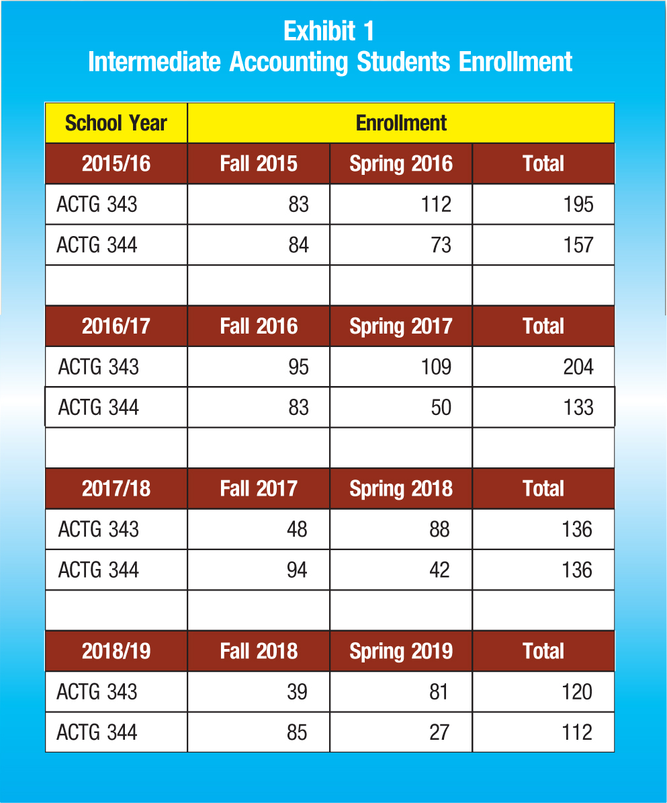

While it might be tempting to ignore the experience of one school as an anomaly, the profile of the accounting program at JMU is typical of major institutions that educate accounting students. The U.S. News and World Report rankings for the 2019 Best Undergraduate Accounting Programs, for example, reported that JMU was tied with Belmont University for 6th place in the category of Regional Universities South (http://bit.ly/2HgQa9l). In terms of the success of JMU accounting majors in competing for job offers upon graduation, Exhibit 2 illustrates the predominance of job offers with public accounting firms for both the Master of Science in Accounting (MSA) students and bachelor students. Finally, Exhibit 3 reports pass rates on the CPA exam for advanced-degree first-time testing events within one year of graduation. This metric is a useful reflection of student readiness to begin their careers in public accounting.

Exhibit 2
Graduate Employment Statistics
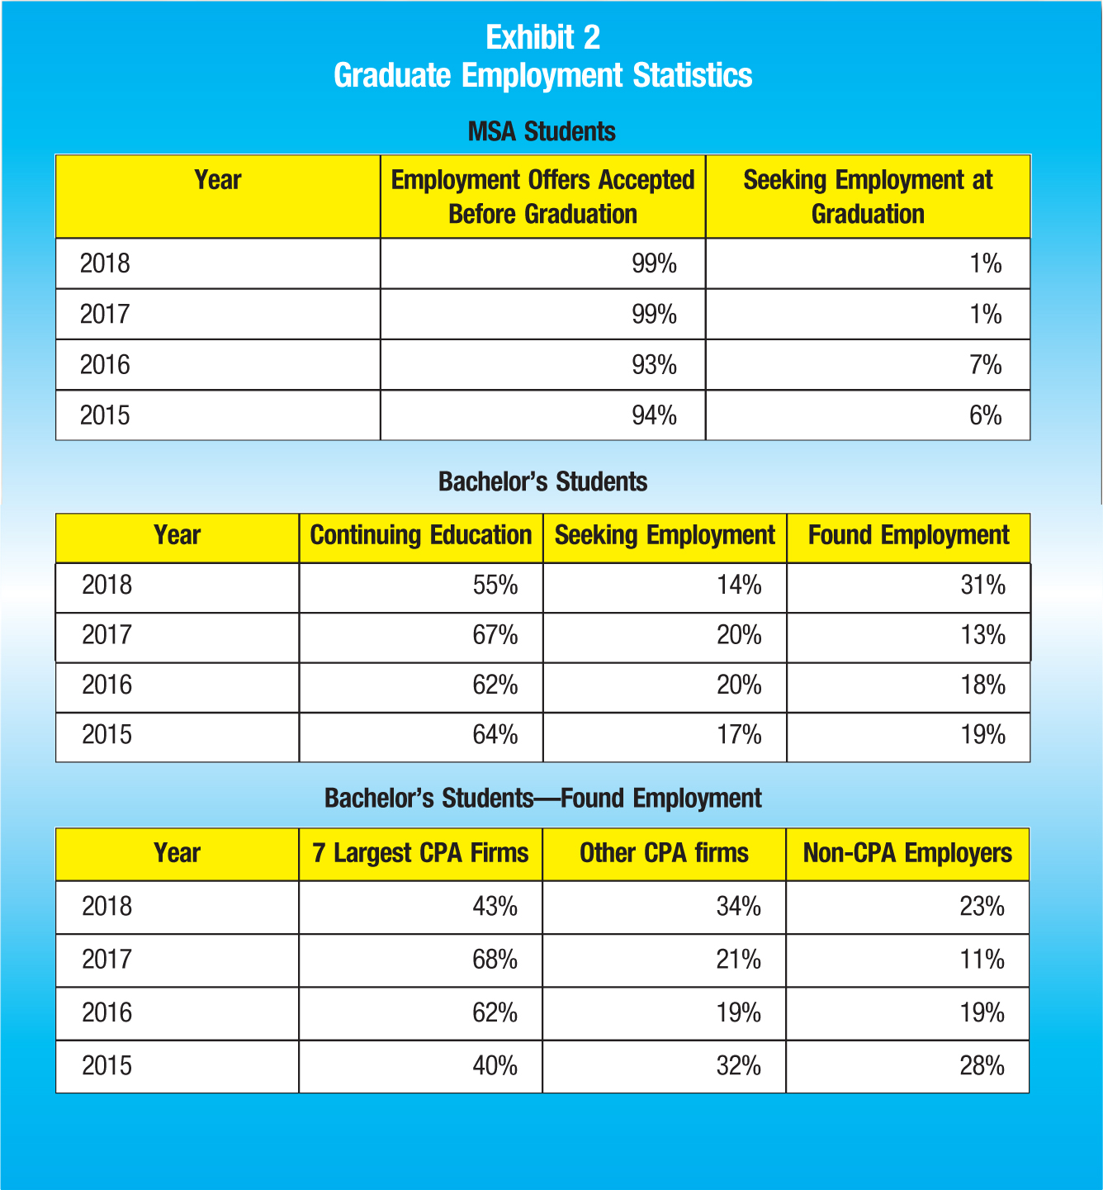

Exhibit 3
Advanced-degree First-time Testing Events within One Year of Graduation
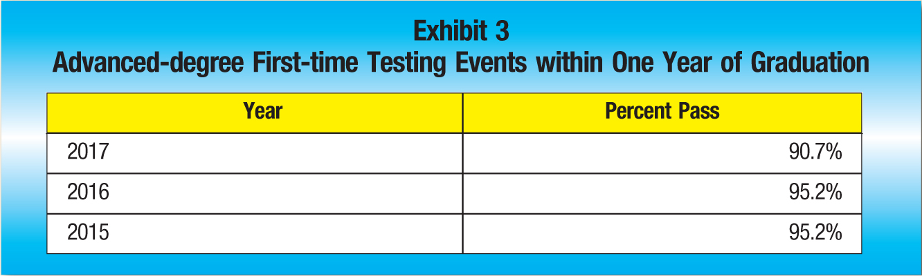

Convergence of Factors
This author believes the experience at JMU for the past several years is not an anomaly to be dismissed; instead, it is an early warning that something significant has changed, perhaps long-term. Student perceptions about the desirability of a career in public accounting may be changing. Unlike the singular disruptions in the 1990s resulting from state boards of accountancy requiring 150-hour mandates, or the impact on student enrollment of the change from paper- to computer-based testing, the root of current disenchantment may be more difficult to identity. The invisible culprit may be a combination of factors that are pushing or attracting bright students away from accounting.
Is the profession properly acknowledging differences in the generation of students now entering college? Are other professions becoming more attractive to top-tier students? Are there structural barriers to getting the CPA that have become onerous? Finally, is the compensation package offered in public accounting sufficiently attractive to compensate for the increased demands being placed on new hires?
Everyone recognizes that rapid change in today’s business environment is the new normal. The accounting profession’s recruitment of college students is not unaffected by this reality. If public accounting firms want to continue to attract the best and the brightest, they need to find out why significant numbers of bright students whom accounting programs have historically attracted are now choosing to go elsewhere.
Alexander L. Gabbin, PhD, CPA is the KPMG LLP Professor of Accounting at James Madison University, Harrisonburg, Va.
CPAJ NEWS BRIEFS: FASB, IASB

